**UML Sequence Diagrams**

**for the**

**SIUE Department of Computer Science**

**CS425 / CS499 Senior Project**

**Software Design and Implementation Courses**

**by**

**Zach Benchley, Matt Lievens, Logan Maughan, Brian Olsen**

**of**



**Learning Outcomes-Based Assessment Database Team**

Revision 1.0

As Of: December 3, 2013

Change Log:

|  |  |
| --- | --- |
| Revision | Change Note(s) |
|  |  |
| 1.0 | * Initial Release |

Reviewed and Approved By:

Name Signature Date

# List of Figures

Figure 1 - MVC Event 4

Figure 2 - Create Class Sequence Diagram 5

Figure 3 - Select Class Sequence Diagram 6

Figure 4 - Add Student Sequence Diagram 7

Figure 5 - Delete Student Sequence Diagram 8

Figure 6 - Add Student Score Sequence Diagram 9

Figure 7 - Change Student Score Sequence Diagram 10

Figure 8 - Student Views Masteries Sequence Diagram 11

Figure 9 - Add Skills Sequence Diagram 12

Figure 10- Teacher Views Skills Sequence Diagram 13

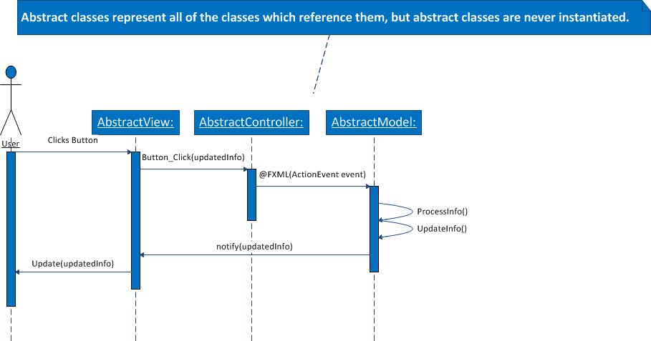

Figure - MVC Event

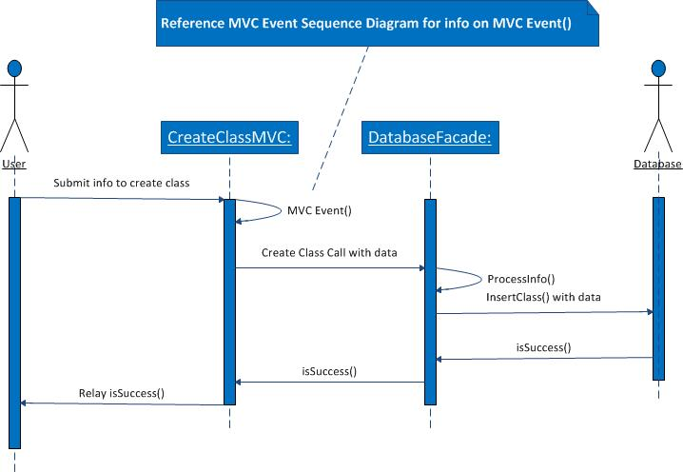

Figure - Create Class Sequence Diagram

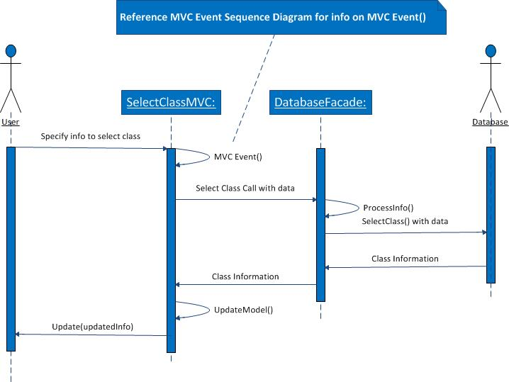

Figure - Select Class Sequence Diagram

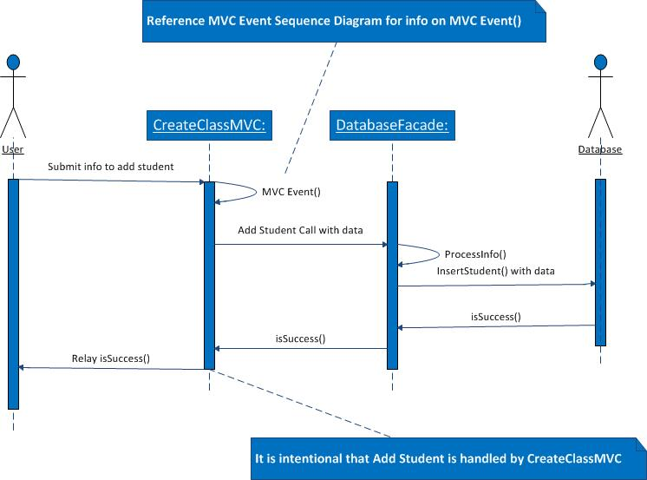

Figure - Add Student Sequence Diagram

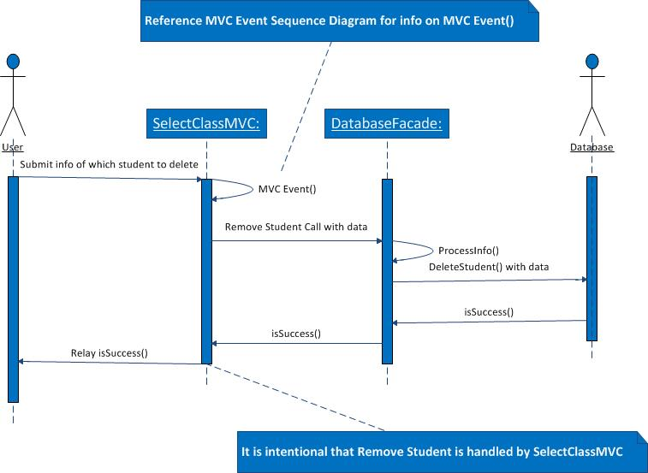

Figure - Delete Student Sequence Diagram

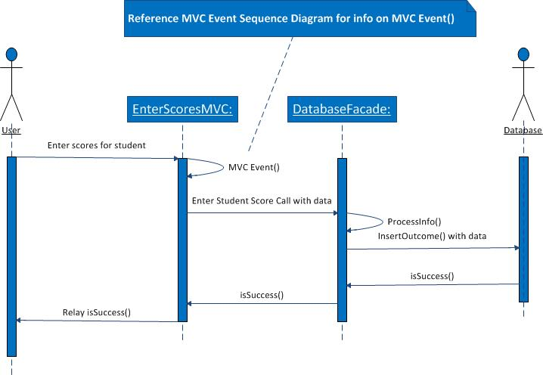

Figure - Add Student Score Sequence Diagram

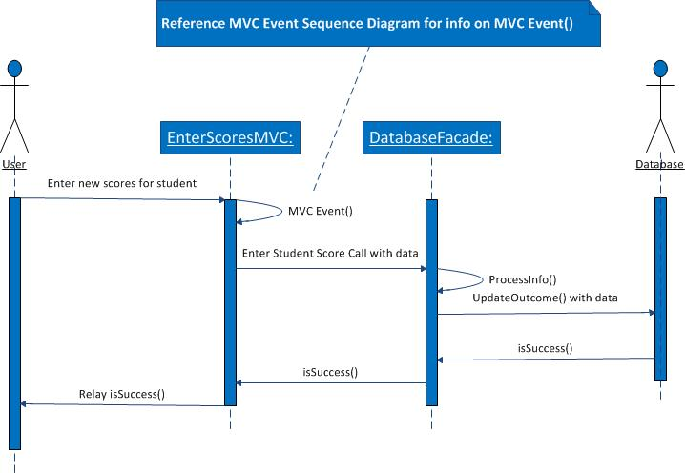

Figure - Change Student Score Sequence Diagram

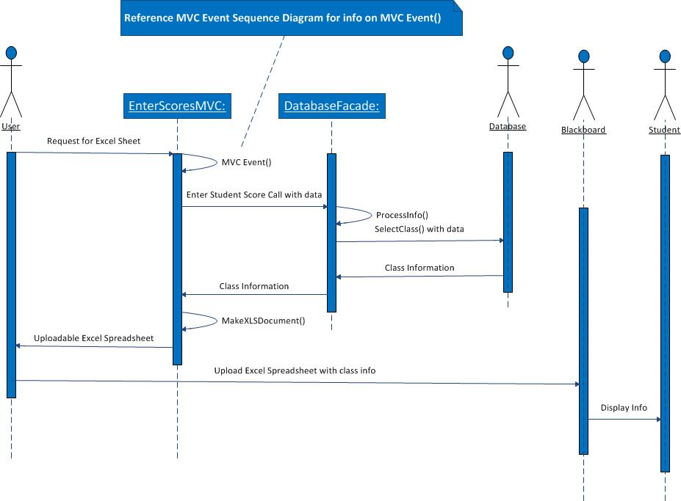

Figure - Student Views Masteries Sequence Diagram

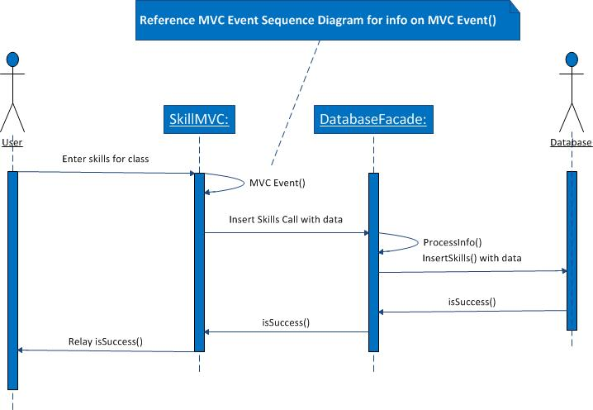

Figure - Add Skills Sequence Diagram

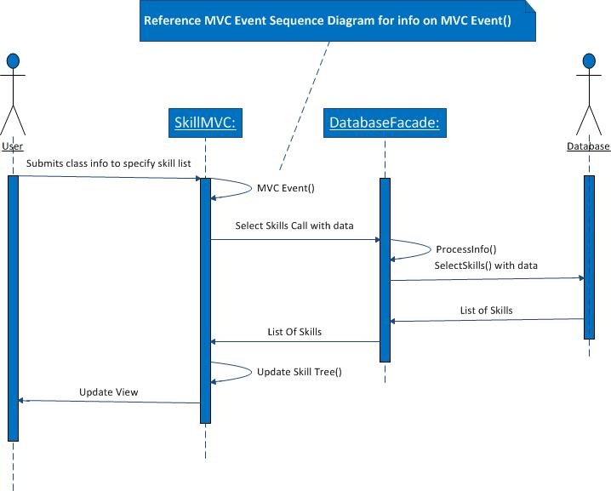

Figure - Teacher Views Skills Sequence Diagram